**#17776** - <https://redmine.vnc.biz/issues/17776>

1. **Description**:

UI/UX of file transfer feature:

- There is a window to display all file transfer sessions

- Each file transfer session:

+ Display progress bar and cancel button

+ Status of file transfer: success, fail, error, cancel/abort.

Workflow:

- Sender request to send a file

- Receiver receives file request, then display a popup accept/deny.

- If receiver accept:

+ Display progress bar and cancel button in file-window

- If receiver deny:

+ Display a denied message in file-window

- If file transfer error, display error message in file-window.

1. **Analytic**
   1. **Root cause**:
   2. **Solutions**:

- UI/UX:

+ Hide/unhidden

+ Close window button

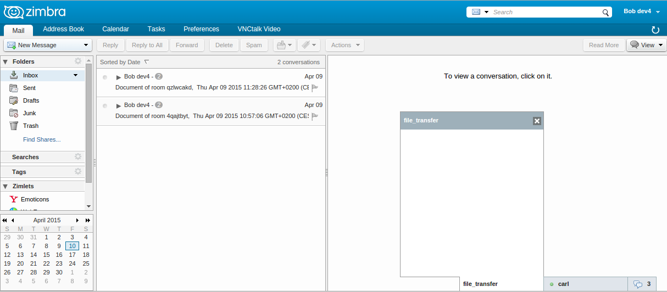

+ Progress bar (css)

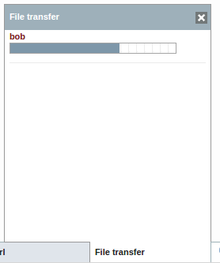

- Add and update message:

+ started (incoming/outgoing)

+ progress

+ decline

+ done (sent/received)

1. **Implementation**
   1. **Code:**

* Create UX/UI File transfer status window:

+ Hide/unhidden

+ Close window button

prosody-packaging/mini/javascripts/mini.js

|  |
| --- |
| /**  * Create status file transfer  */  self.createFileTransferStatus = function() {  var hash = 'file_transfer';  var nick = 'File transfer';  var type = 'chat';  var html = '<div class="jm_conversation jm_type_' + type + '" id="chat-' + hash + '" data-type="' + type + '" data-nick="' + JappixCommon.escapeQuotes(nick) + '" data-hash="' + hash + '">' +  '<div class="jm_chat-content">' +  '<div class="jm_actions">' +  '<span class="jm_nick">' + nick + '</span>' +  '<a class="jm_one-action jm_close jm_images" title="' + JappixCommon._e("Close") + '" href="#"></a>' +  '</div>' +  '<div class="jm_pix_stream"></div>' +  '<div class="jm_received-messages" id="received-' + hash + '">' +  '</div>' +  '</div>' +  '<div class="jm_one-action">'+  '<a class="jm_pane jm_chat-tab jm_file-transfer-tab jm_images" href="#" id="jm_a_'+ hash +'">' +  '<span class="jm_name">' + nick.htmlEnc() + '</span>' +  '</a>' +  '</div>';  var file_transfer_parse = jQuery(jQuery.parseHTML(html));  file_transfer_parse.find('a.jm_close').click(function(){  var current_sel = file_transfer_parse;  current_sel.stopTime().remove();  });  if (jQuery('#jappix_mini div.jm_conversations').find('a.jm_file-transfer-tab').length == 0) {  jQuery('#jappix_mini div.jm_conversations').prepend(file_transfer_parse);  }  // add click file transfer event  file_transfer_parse.find('a.jm_file-transfer-tab').click(function() {  // Using a try/catch override IE issues  try {  if(!jQuery(this).hasClass('jm_clicked')) {  // Show it!  self.switchPane('chat-file_transfer', 'file_transfer');  } else {  self.switchPane();  }  } catch(e) {}  finally {  return false;  }  });  } |

* Add progress bar:

**Display**: prosody-packaging/mini/javascripts/mini.js

|  |
| --- |
| self.DisplayFileTransferStatus = function(session,action) {  ….  var fileTag = jQuery('#jappix_mini #chat-file_transfer div.jm_group').filter('#' + session.sid);  var html = '<p><i>' + session.filename + '</i></p>' +  '<progress value="' + session.value + '" max="' + session.size +'"></progress>';  fileTag.find('p').html(html);  return;  …. |

**CSS**:prosody-packaging/mini/stylesheets/mini.css

|  |
| --- |
| #chat-file_transfer progress {  height: 14px;  width: 85%;  } |

* **Add and update message:**

|  |
| --- |
| /**  * Display message and progress file transfer  * @param session  * @param session.issend (boolean)  * @param session.sid  * @param session.from  * @param session.to  * @param session.filename  * @param session.size  * @param session.value  * action:  * + started (incoming/outgoing)  * + progress  * + decline  * + cancel  * + error  * + done (sent/received)  */  self.DisplayFileTransferStatus = function(session,action) {  if (action === 'progress' ) {  var fileTag = jQuery('#jappix_mini #chat-file_transfer div.jm_group').filter('#' + session.sid);  var html = '<p><i>' + session.filename + '</i></p>' +  '<progress value="' + session.value + '" max="' + session.size +'"></progress>';  fileTag.find('p').html(html);  return;  }  switch(action) {  case 'started':  if (session.issend) {  body = 'Share a file: ' + session.filename + ', size: ' + Math.floor(session.size/1024) + 'kb';  } else {  body = 'Accept to receive ' + session.filename;  }  break;  case 'done':  if (session.issend) {  body = 'Sent file completed';  } else {  body = 'Receive ' + session.filename + ' successfully'  }  break;  case 'decline':  if (session.issend) {  body = 'File transfer ' + session.value;  } else {  body = 'Deny to receive ' + session.filename;  }  break;  case 'error':  break;  case 'cancel':  break;  default:  // Ignore  }  self.DisplayMessageFileTransferStatus(session.sid,session.to,body);  }  /**  * Create and update message file transfer  * @param sid  * @param buddy  * @param body  */  self.DisplayMessageFileTransferStatus = function(sid,buddy,body) {  var nick = buddy.substring(0,buddy.indexOf("@"));  var fileTag = jQuery('#jappix_mini #chat-file_transfer div.jm_group').filter('#' + sid);  if(fileTag.length > 0) {  //Update message  fileTag.find('p').text(body);  } else {  //Create message  var html = '<div class="jm_group jm_user-message" data-type="user-message-message" data-stamp="' +  JappixDateUtils.getTimeStamp() + '" id="' + sid + '">' +  '<b class="jm_name jm_him">' + nick + '</b>' +  '<p>' + body + '</p>' +  '</div>'  jQuery('#jappix_mini #chat-file_transfer div.jm_received-messages').append(html);  //Auto ScrollTop  self.messageScroll('file_transfer');  }  } |

* **Catch event and add message:**

**Receiver:**

|  |
| --- |
| self.initFileTransferSession = function(){  …  self.createFileTransferStatus();  var session = {  issend: false,  sid: receiverSession.sid,  from: receiverSession.peer.bare,  to: receiverSession.parent.jid.bare,  filename: receiverSession.receiver.metadata.name,  };  var dialog = appCtxt.getYesNoMsgDialog();// get a simple message dialog  dialog.reset(); // reset the dialog  dialog.setMessage(JappixCommon.bareXID(receiverSession.peerID) + " would like to share a file '" + receiverSession.receiver.metadata.name + "' with you." , DwtMessageDialog.INFO_STYLE); // set the message "info" style  dialog.setButtonListener(DwtDialog.YES_BUTTON,new AjxListener(this,function(){  dialog.popdown();  receiverSession.accept();  self.switchPane('chat-file_transfer', 'file_transfer');  self.DisplayFileTransferStatus(session,'started');  }));  dialog.setButtonListener(DwtDialog.NO_BUTTON,new AjxListener(this,function(){  dialog.popdown();  receiverSession.decline();  self.DisplayFileTransferStatus(session,'decline');  }));  dialog.popup();  receiverSession.receiver.on('progress', function (recvd, total) {  log('Received from '+receiverSession.peerID+': ' + recvd + '/' + total);  session.size = total;  session.value = recvd;  self.DisplayFileTransferStatus(session,'progress');  });  receiverSession.on('receivedFile', function (receiverSession, file, metadata) {  log('Received file', metadata.name, metadata.size);  var downloadURL = window.webkitURL.createObjectURL(file);  var aLink = document.createElement("a");  aLink.href = downloadURL;  aLink.download = metadata.name;  aLink.click();  self.DisplayFileTransferStatus(session,'done');  });  ... |

**Sender:**

|  |
| --- |
| self.startFileTransfer = function(buddy){  …  self.createFileTransferStatus();  self.switchPane('chat-file_transfer', 'file_transfer');  log('Offering:', file.name, file.size, file.type, file.lastModifiedDate);  transferSession = self.client.jingle.createFileTransferSession(buddy + "/file_transfer");  var session = {  issend: true,  sid: transferSession.sid,  from: transferSession.parent.jid.bare,  to: buddy,  filename: file.name,  size: file.size  };  transferSession.sender.on('progress', function (sent, total) {  log('Sent to ' + buddy + ': ' + sent + '/' + total);  session.value = sent;  self.DisplayFileTransferStatus(session,'progress');  });  transferSession.on('terminated',function(transferSession,reason){  session.value = reason.condition;  if (reason.condition == 'success') {  self.DisplayFileTransferStatus(session,'done');  }else{  self.DisplayFileTransferStatus(session,'decline');  }  });  transferSession.start(file);  var hash = hex_md5(buddy);  var meta = {"name": file.name,"algo":"sha-1","hash":hash};  transferSession.sender.on('sentFile',function(meta){  self.DisplayFileTransferStatus(session,'done');  });  self.DisplayFileTransferStatus(session,'started');  .... |